Problem 1: what is the total number of crime in London in 2022?



Problem 2: What is the top 3 areas in crime?

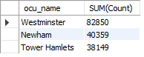

Problem 3: What is top 3 crime sections in London?

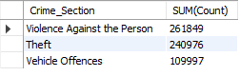

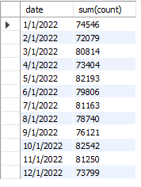Problem 4: What is the total crime each month?

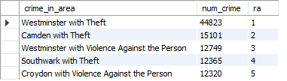Problem 5: What is top 5 crime section in area?